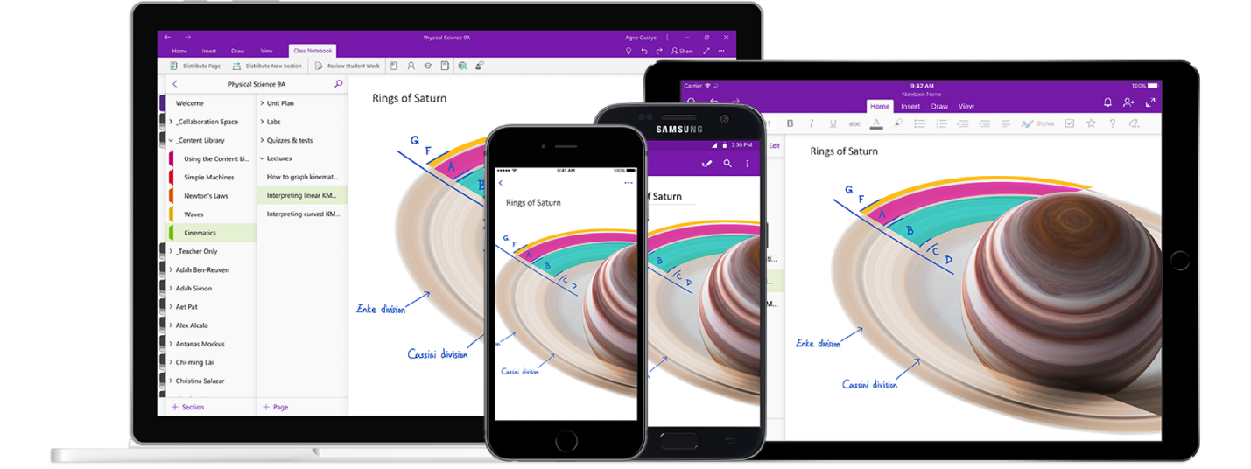

Figure 1 cited from [Microsoft OneNote’s Official Website](https://www.microsoft.com/zh-cn/microsoft-365/onenote/digital-note-taking-app?ms.url=onenotecom&rtc=1)

Analyzing the Design of Microsoft OneNote - version 16.0.13530.20440 or later

Software Analysis and Design Report | Jan 30th 2021 | Hairong Wu (Jason) | 1683 words

# About the Product

Microsoft OneNote is one of the bundled software in Microsoft 365 series. It focuses on providing both students and workers in various fields with simple and powerful features to take notes. One can simply click on the small icon within the task bar and start recording their contents. Users can also create different notebooks for various purpose, by naming a notebook can they recognize what this notebook is used for. In addition, within a notebook, tabs can be created to filter huge sections of users’ projects or lectures. They can also add pages for detailed contents, pictures and drawing.

I choose to make a research on Microsoft OneNote is because I’m always one of the stakeholders of it and, with no doubt, this software would keep influencing its stakeholders by providing new features which might have advantages or drawbacks. It is indeed that the latest version of OneNote (I believe starting at the version of 16.0.13530.20440 or later) has great updates on both its features and software layouts, which has costed effects not only on me but on other stakeholders and even several potential future users; for instance, users who prefers to create plenty of tabs would find it hard to switch between their tabs because all the tabs will be automatically combined.

Therefore, in this research paper, I will discuss on the current direct stakeholders, indirect stakeholders, design critiques and a redesign proposal for a possible prototype

# Stakeholder Research

## Direct Stakeholders

All students, especially those in high school and in college, and workers are direct stakeholders. After researching, students and workers who prefers to use a Windows system or Microsoft device such as Surface books are more likely to be direct stakeholders. There are two main reasons why they use OneNote instead of other kinds of notebook software.

Firstly, they are using Microsoft 365, so OneNote is pre-installed on their computer which they can use it as a tool immediately after they got their new computer. These stakeholders also prefer to use OneDrive instead of other cloud syncing system like iCloud. Therefore, using whole series of Microsoft products can facilitate their working experience via software such as Microsoft word, Microsoft PowerPoint, and Microsoft Outlook.

Secondly, OneNote could provide a better experience while using a touchscreen device like iPad and Surface book series. One can easily take notes through OneNote just like taking notes on a real notebook and have the same experience comparing to writing on papers.

The two conclusions are derived through my interviews and surveys to these stakeholders. I send links to students in both US and Chinese high schools and colleges, and my internship colleagues. I also post the survey on social networks for receiving genuine responses.

For these stakeholders, they think OneNote provides them a better method to make their work easier. They can always find the features they want and utilize tools to achieve at they expected; for instance, if they want to create a polynomial graph and draw lines and dots on it, they could easily do so and make drawings on it, just like how they do this on their physical notebooks.

Unfortunately, the current OneNote version does make sense to those touchscreen users, however, for those who are using a computer and tablet, they are facing the same issue on the annoying design of tab switching, drawing function, and editing features such as resizing and colorize text. These features should be designed clear and simple for them. However, they are now confused by these functions and even do not know how to find these things and thus utilize them.

## Indirect Stakeholders

Indirect stakeholders are those who prefer to use other notebook system and Apple users who are using iClouds. They are considered as indirect stakeholders is because: 1) other notebook software sometimes does not make sense to them, probably having issues and bugs which does not represent its unique features, 2) Microsoft OneNote is now supporting to be sync by iCloud and can be well-utilized on Apple devices. Therefore, these users are somehow potential and future users of OneNote. In addition, the current design for OneNote does fit to these indirect stakeholders’ taste, such as supporting to cooperate with system and software that are not Microsoft products, and would attract them to use it.

# Design Critique (do not forget to check out our design critique resources)

The next step is to dive into the details of the design to determine exactly why it is not satisfying your stakeholder groups. Analyze the overall user experience as well as the detailed interaction design. If a software user interface is involved, analyze it according to the principles you read about and discussed in class. Consider how accessible the design is for people with varying levels of ability. If relevant, also consider whether the security of the system adequately addresses your stakeholders' goals and values.

Add a section to your paper in which you discuss the various problems you discovered. Include **at least 2 significant problems**, and for each, explain in detail why you think it is a problem. If it's an interaction design problem, be sure to use the interaction design vocabulary to explain what's wrong. If it's a UI problem, reference the relevant UI design principles. Include pictures or screenshots that illustrate the problem.

## Problem 1 Label

**Make sure to tie this back into your stakeholders!**

Lorem ipsum dolor sit amet, consectetur adipiscing elit. Vestibulum quis tellus aliquam ligula congue dapibus et eget erat. Maecenas iaculis est non laoreet pellentesque. Sed ut diam sagittis, tincidunt leo vitae, ornare lectus. Nulla tempor sapien quam, eu convallis odio ultrices et. Nunc bibendum, enim sed faucibus cursus, nibh nisi dapibus enim, ut condimentum diam tortor ut mauris. Proin et tempus dolor, ut aliquet enim. Nulla et elementum tortor. Morbi nunc enim, finibus eu sagittis nec, ornare vel tellus. Interdum et malesuada fames ac ante ipsum primis in faucibus. Vestibulum ac tellus nisi. Quisque eget feugiat ex. Lorem ipsum dolor sit amet, consectetur adipiscing elit. Aenean bibendum, nulla ac euismod vestibulum, urna est fermentum massa, ut posuere erat augue pretium tellus.

Etiam imperdiet mollis ultricies. Sed ac tortor vestibulum orci laoreet consequat. Morbi eu enim molestie, hendrerit felis ut, iaculis nisi. Class aptent taciti sociosqu ad litora torquent per conubia nostra, per inceptos himenaeos.

*Do not forget to include an annotated screenshot or picture of the problems in the product you are critiquing. Below is an example of how you can annotate the problems in the UI of a software or app.*  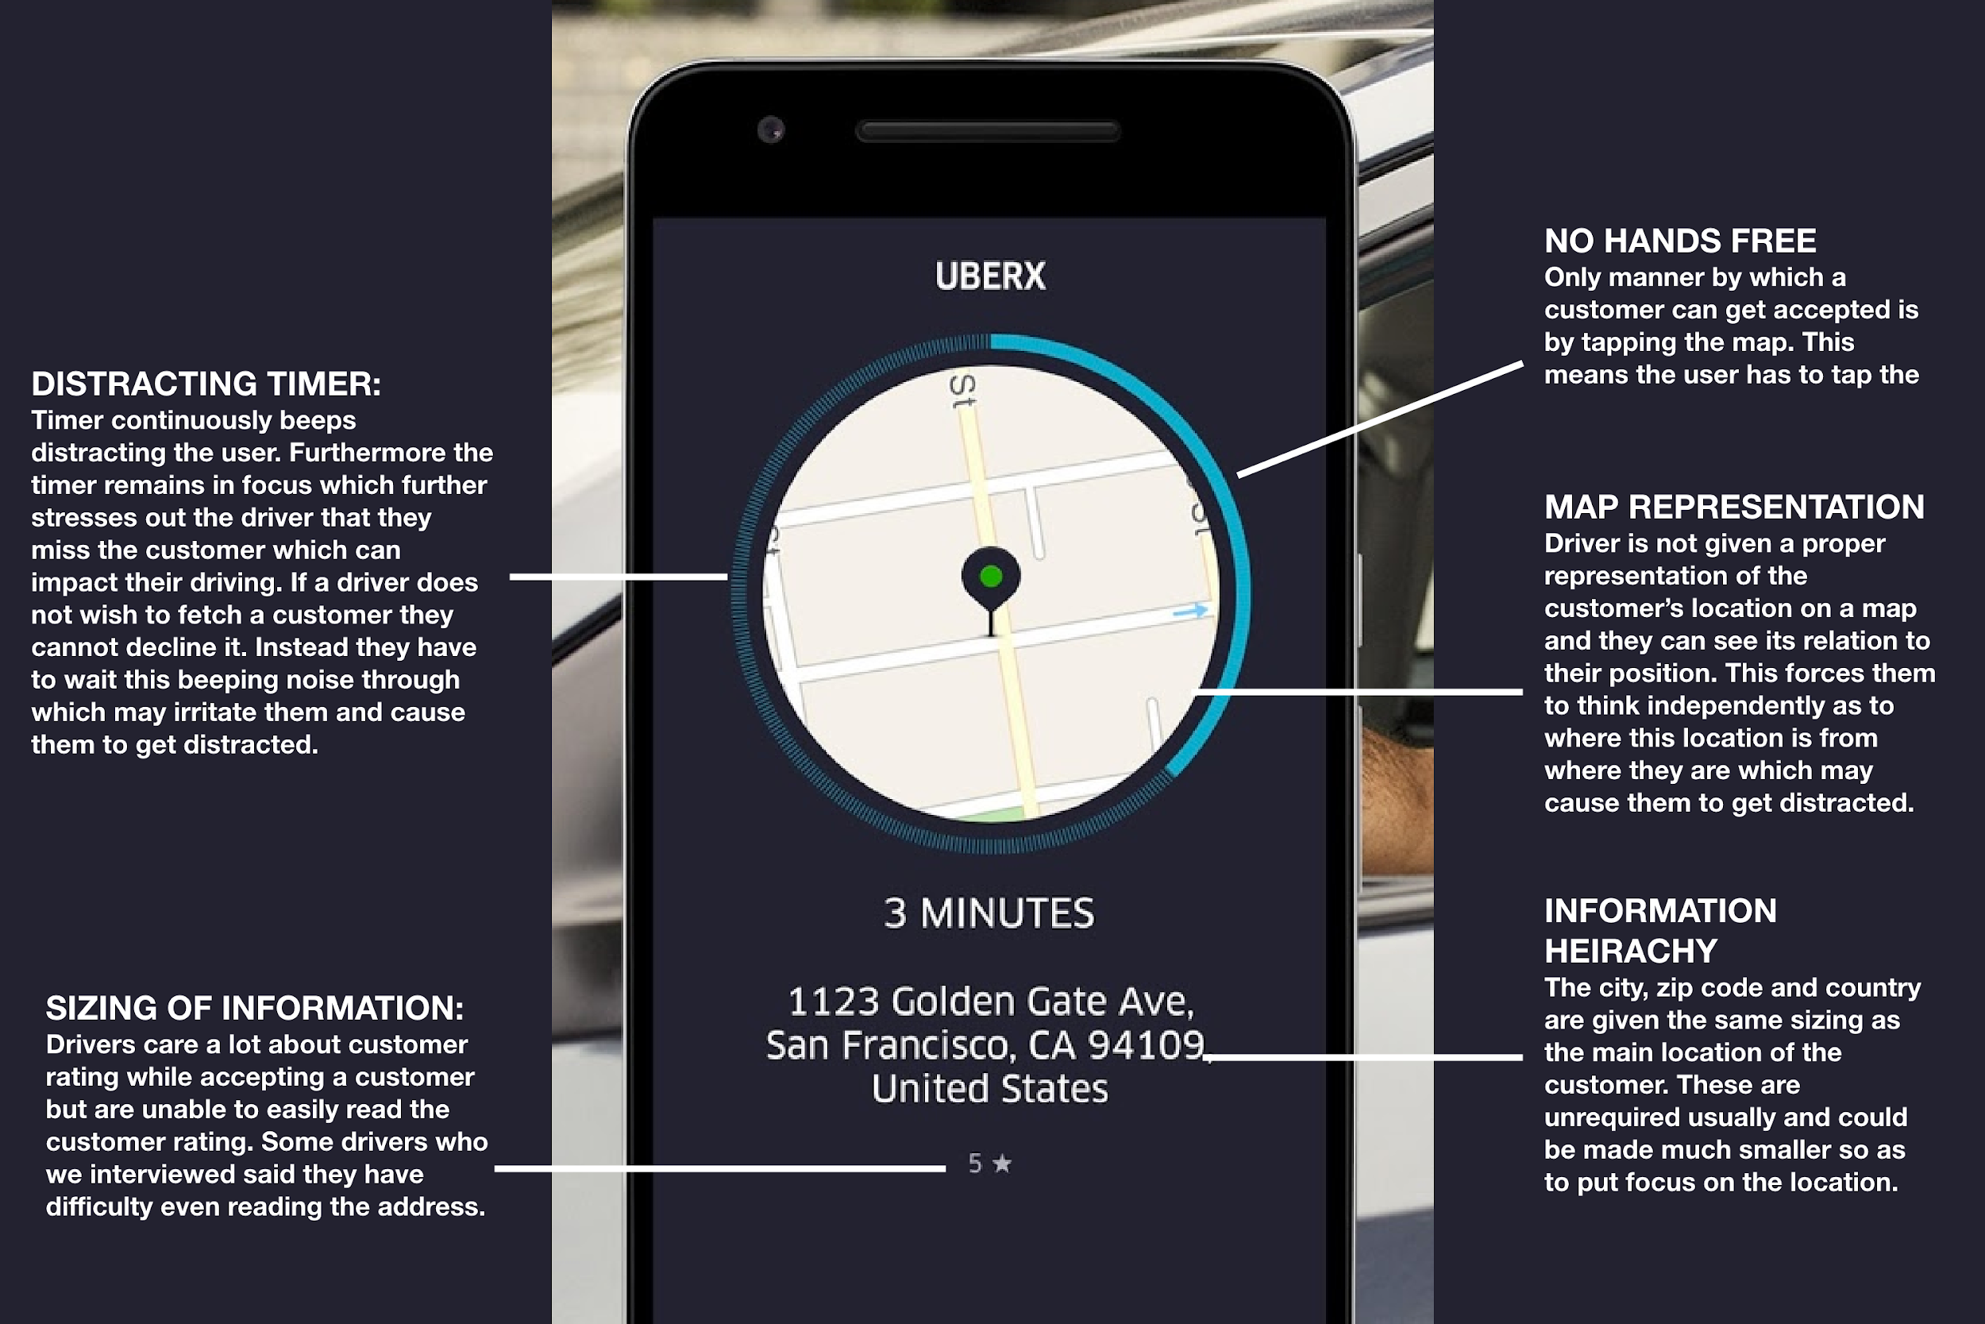

## Problem 2 Label

*Do not forget to include an annotated screenshot or picture of the problems in the product you are critiquing. Below is an example of how you can annotate the problems in the UI of a software or app.*

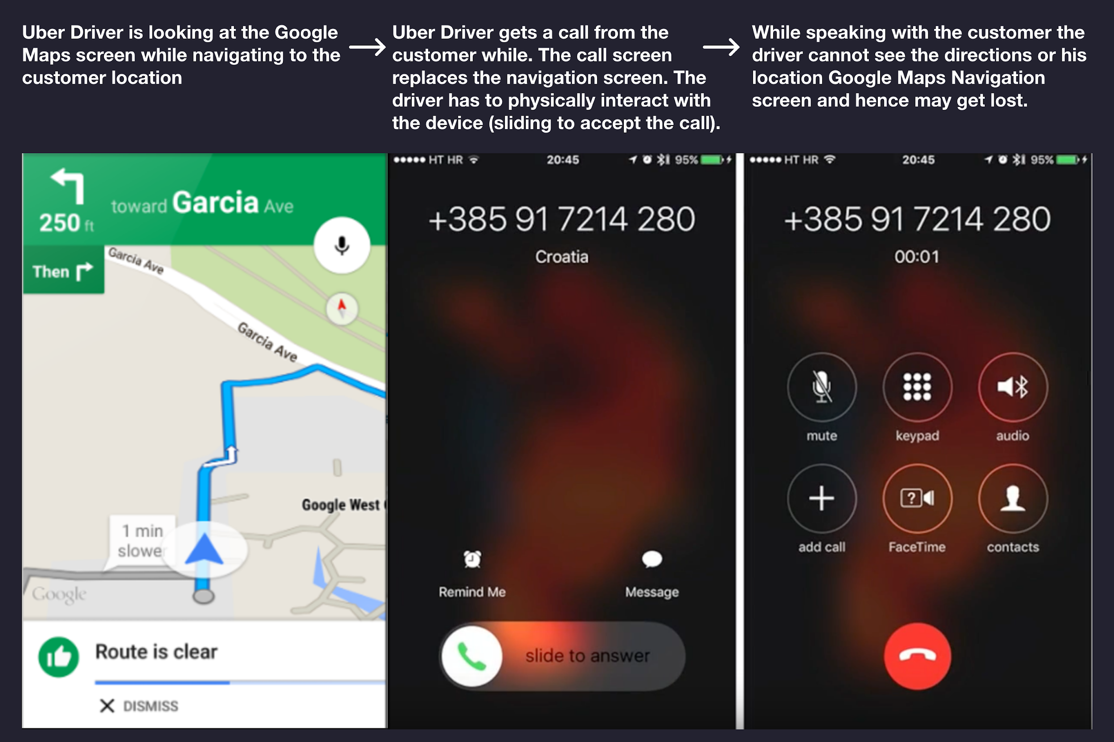

**Make sure to tie this back into your stakeholders!**

Lorem ipsum dolor sit amet, consectetur adipiscing elit. Vestibulum quis tellus aliquam ligula congue dapibus et eget erat. Maecenas iaculis est non laoreet pellentesque. Sed ut diam sagittis, tincidunt leo vitae, ornare lectus. Nulla tempor sapien quam, eu convallis odio ultrices et. Nunc bibendum, enim sed faucibus cursus, nibh nisi dapibus enim, ut condimentum diam tortor ut mauris. Proin et tempus dolor, ut aliquet enim. Nulla et elementum tortor. Morbi nunc enim, finibus eu sagittis nec, ornare vel tellus. Interdum et malesuada fames ac ante ipsum primis in faucibus. Vestibulum ac tellus nisi. Quisque eget feugiat ex. Lorem ipsum dolor sit amet, consectetur adipiscing elit. Aenean bibendum, nulla ac euismod vestibulum, urna est fermentum massa, ut posuere erat augue pretium tellus.

Etiam imperdiet mollis ultricies. Sed ac tortor vestibulum orci laoreet consequat. Morbi eu enim molestie, hendrerit felis ut, iaculis nisi. Class aptent taciti sociosqu ad litora torquent per conubia nostra, per inceptos himenaeos. Nunc sed sem urna. In ut accumsan dui. Quisque ultrices, est quis euismod ultricies, velit ante consequat enim, at dignissim mauris lacus eget urna. Aliquam egestas odio vitae leo rhoncus bibendum.

## Design Critique Tips and Resources

When critiquing a design do not forget to make use of the appropriate design key terms and make reference to good design principles not followed. If you refer to an article do not forget to cite it.

*We recommend that you read the following articles on the principles of interaction design, affordances and signifiers:*

* <https://medium.com/@sachinrekhi/don-normans-principles-of-interaction-design-51025a2c0f33>
* <https://medium.com/@Ben.Olson/affordances-and-signifiers-in-mobile-interface-design-cf584696cda8>
* <https://www.uxbooth.com/articles/complete-beginners-guide-to-information-architecture/>
* <https://uxdesign.cc/psychology-design-4-gestalt-principles-to-use-as-your-next-design-solution-fcdec423a6bf>
* <https://lawsofux.com/>
* <https://goodui.org/>

Below are some important key terms and their definitions:

**Affordances:**

An affordance is what an object can do based on user interaction.

**Example:**

A chair reveals its affordance by design, its shape mirrors the body and communicates its intent: to be sat on.

However, a chair has an additional affordance not communicated by its design. A chair can be used to change a light bulb or reach a book, a hidden affordance.

**Signifiers:**

A signifier clarifies an affordance, it illustrates or describes what an object can do. A signifier can be blatantly obvious or very subtle.

**Example:**

A door may have a slot. The slot is an affordance — objects may be placed through the hole. However, the slot may be accompanied by the text “Mail” which is a signifier that indicates the purpose of the affordance by offering instructions on what objects should be placed through the hole.

**Mapping**

Mapping is about having a clear relationship between controls and the effect they have on the world.

**Visibility**

Visibility is the basic principle that the more visible an element is, the more likely users will know about them and how to use them.

**Feedback**

Feedback is the principle of making it clear to the user what action has been taken and what has been accomplished.

# Redesign Proposal

Lastly, add a section to your paper in which you propose changes to the design thatfix **one of the problems you identified**, for the stakeholders you identified. This problem should be fundamental to the use of the product. If possible, include drawings or mock-ups of your proposed changes.

For example, if you found problems with the UI design, include sketches of a better UI and describe how your new UI better adheres to the UI design principles. If you found problems with the interaction design, include sketches of a better design that address those problems, and use the interaction vocabulary to explain why it's better. **Include these sketches in your paper** so that we can better understand your redesign.

*When proposing your design ideas do not forget to mention the assumptions you made, the limitations and alternate designs which you could consider.* ***Show two design variations of your idea****, or mention other possible variations on each redesign.*

*If you iterated through various ideas, show that through a picture of all your ideas together. We like to see your design thinking process.*

## Idea 1 - Redesign of Issue

Vestibulum ac tellus nisi. Quisque eget feugiat ex. Lorem ipsum dolor sit amet, consectetur adipiscing elit. Aenean bibendum, nulla ac euismod vestibulum, urna est fermentum massa, ut posuere erat augue pretium tellus.Vestibulum ac tellus nisi. Quisque eget feugiat ex. Lorem ipsum dolor sit amet, consectetur adipiscing elit. Aenean bibendum, nulla ac euismod vestibulum, urna est fermentum massa, ut posuere erat augue pretium tellus.

Vestibulum ac tellus nisi. Quisque eget feugiat ex. Lorem ipsum dolor sit amet, consectetur adipiscing elit. Aenean bibendum, nulla ac euismod vestibulum, urna est fermentum massa, ut posuere erat augue pretium tellus. Vestibulum ac tellus nisi. Quisque eget feugiat ex. Lorem ipsum dolor sit amet, consectetur adipiscing elit. Aenean bibendum, nulla ac euismod vestibulum, urna est fermentum massa, ut posuere erat augue pretium tellus.

*Do not forget to include a high-quality annotated screenshot or picture of the redesign you made. It can be a simple low fidelity sketch or a high-fidelity wireframe.*

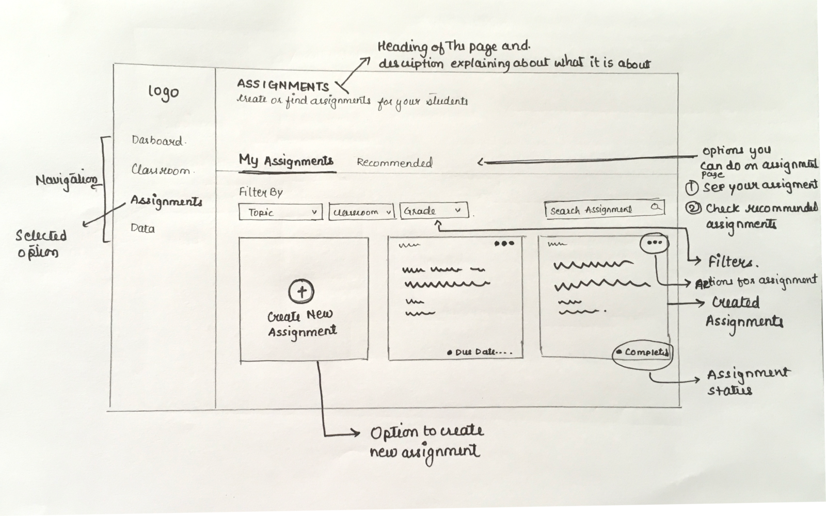

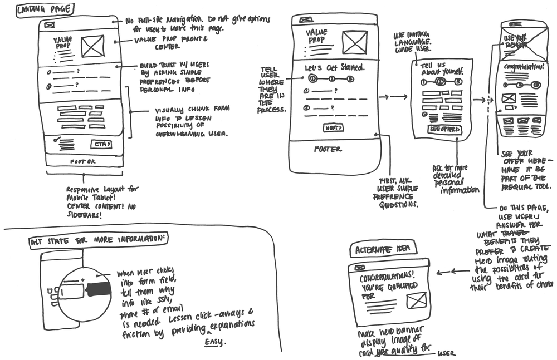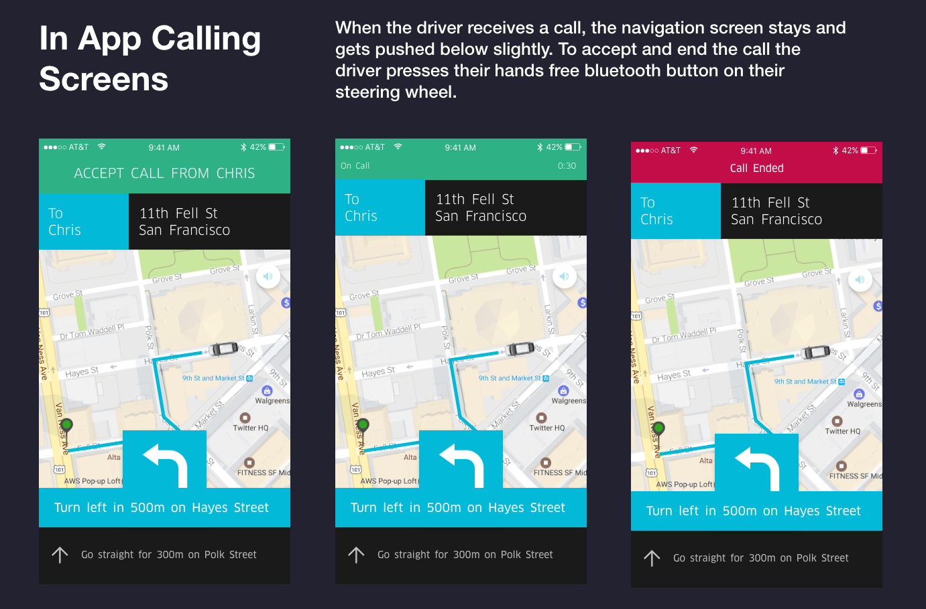

## 

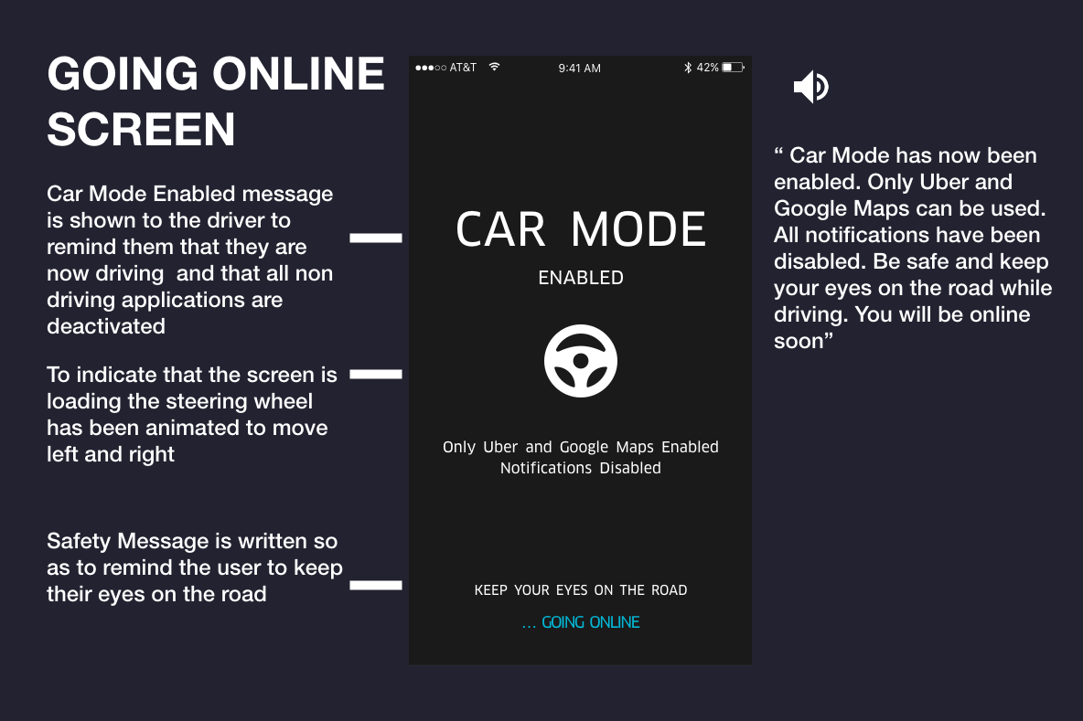

# References

Use APA. Do not forget to cite the websites and articles you refer to.

# Appendix

* Interview Transcripts
* Survey Results
* Additional screenshots
* More design ideas and wireframes
* More information about the product

There is no minimum length for the paper, just be sure you addressed all the questions. Max length is ~1750 words **excluding references and the appendix**. If you reference external sources, be sure to cite those sources properly. You may want to re-read the plagiarism section of the course syllabus page.